#________
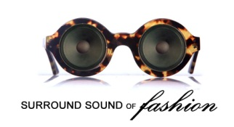
BRING (2) TWO PICTURES
REGISTRATION FORM (PLEASE PRINT AND BRING TO CASTING CALL)
SUNDAY, AUGUST 29, 2021
DTLR
205 W. 87th Street
Chicago, IL
Time: 12pm – 3pm CST
CIRCLE YOUR CATEGORY: MODEL*DESIGNER*
DESIGNERS
Designer Name:____________________________
Website: ________________________ Instagram: _________________
Note: Please bring garments for the judges to review.
CONTACT (ALL REGISTRANTS)
First Name: ___________________ Last Name:________________
Age:_________________________
Address:______________________ City/State/Zip: __________________
Email Address: _________________________________ (make legible)
Phone tel#:(_____)________________________________
MODEL SECTION (ONLY)
Sex __________________ Ethnicity: ___________________________
Height: ________________ Weight: ______________
Bust/Chest: _______________ Waist: ___________________________
Hips: ____________________ Shoe Size: ________________________
Experience: ____________________ Beginner, Intermediate or Advanced
Facebook: _________________________ Twitter: ___________________
Instagram: ______________________
MODELS AVAILABILITY – CHICAGO REHEARSAL/EVENT
PLEASE NOTE: YES OR NO
MAIN EVENT: SUNDAY, OCTOBER 24th (11am – 7pm) ____________________

